**Assignment: 2**

1. Without blocks: Move the blue circle to the red circle (as discussed in class). The movement cannot be diagonal. Come up with a path (with the least number of steps) with a mathematical rationale.  
2. With blocks: Repeat the same exercise and see if the logic can be applied when there are blocks.

| 15 | 16 | 17 | 18 | 19 |
| --- | --- | --- | --- | --- |
| 10 | 11 | 12 | 13 | 14 |
| 5 | 6 | 7 | 8 | 9 |
| 0 | 1 | 2 | 3 | 4 |

**Ans 1:** Suppose we have to find out the shortest path between square 0 and 19, we will consider 0 as our start point and 19 as our end point.

1. Considering 0 as the start point, first of all we will consider what are the possibilities to move from point 0 position towards 19(end point). As we have UP, DOWN, LEFT, RIGHT vectors only. We can only move from 0 to 5(Up) and 1(Right).

| 15 | 16 | 17 | 18 | 19 |
| --- | --- | --- | --- | --- |
| 10 | 11 | 12 | 13 | 14 |
| 5 | 6 | 7 | 8 | 9 |
| 0 | 1 | 2 | 3 | 4 |

Sequence: 0,1,5

1. Now we will start making a sequence of visited square numbers and continue with the first again but on current squares (5 and 1)

Now from 1 we can move to 6 and 2; from 5 we can move to 10 and 6. In the sequence we will consider 6 only single time not twice as we are making a unique sequence.

| 15 | 16 | 17 | 18 | 19 |
| --- | --- | --- | --- | --- |
| 10 | 11 | 12 | 13 | 14 |
| 5 | 6 | 7 | 8 | 9 |
| 0 | 1 | 2 | 3 | 4 |

Updated Sequence: 0,1,5,6,2,10

1. Like this, we will keep on traversing through the matrix to reach each square one by one and so on

| 15 | 16 | 17 | 18 | 19 |
| --- | --- | --- | --- | --- |
| 10 | 11 | 12 | 13 | 14 |
| 5 | 6 | 7 | 8 | 9 |
| 0 | 1 | 2 | 3 | 4 |

Visiting all the squares we will obtain a sequence in the end:

**0, 1, 5, 6, 2, 10, 11, 7, 3, 15, 16, 12, 8, 4, 17, 13, 9, 18, 16, 14, 19**

As all the squares are equal, so when 1 unit movement will take place we will add it up everytime, starting from 0 units at the start point to find the shortest distance after every unit movement.

To find the shortest path, we would start traversing back from 19(end point) to 0(start point).

Marking 19 as the current square we can move from either 14 or 18 and so on we will create a whole network of shortest paths that can be possible.

In the network from start to end point we will observe bold and dotted lines, the bold lines represent forward movement from end to start and dotted represent backtracking to the squares that have already been visited.

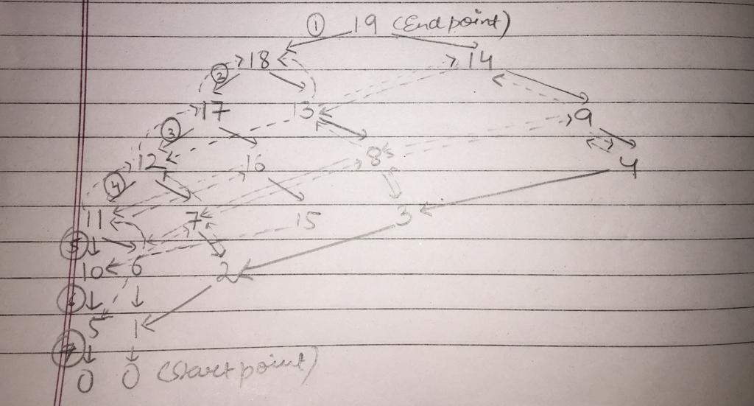

In this network we will observe 7 levels which are been explored one by one, which tells us that the shortest path will be of 7 units movement only.

1 + 1 + 1 + 1 + 1 + 1 + 1 = 7unit

Considering 1st square at all levels we will obtain shortest path: 19 🡪 18 🡪 17 🡪 12 🡪 11 🡪 10 🡪 5 🡪 0

Similarly, other shortest routes can be obtained considering the other squares at different levels in the grid at a time as these squares are of equal sizes in the whole grid, the other short paths obtained will also be minimum 7 units.

**Ans 2:** If Blockers at 5th and 7th square are present in the grid of squares

| 15 | 16 | 17 | 18 | 19 |
| --- | --- | --- | --- | --- |
| 10 | 11 | 12 | 13 | 14 |
| 5 | 6 | 7 | 8 | 9 |
| 0 | 1 | 2 | 3 | 4 |

This will imply that the possibility of moving from 5th and 7th square is cancelled. So that we will eliminate them from the sequence we created in the previous answer.



0, 1, 5, 6, 2, 10, 11, 7, 3, 15, 16, 12, 8, 4, 17, 13, 9, 18, 16, 14, 19 (Old sequence)

**0, 1, 6, 2, 10, 11, 3, 15, 16, 12, 8, 4, 17, 13, 9, 18, 16, 14, 19** (New sequence after eliminating 5 & 7)

In the new network graph after the elimination of 5th and 7th square the new shortest path will move towards the nearest square at that particular level and move towards the start point.

From here we will compare old shortest path (without blockers) and new shortest path(with blockers)

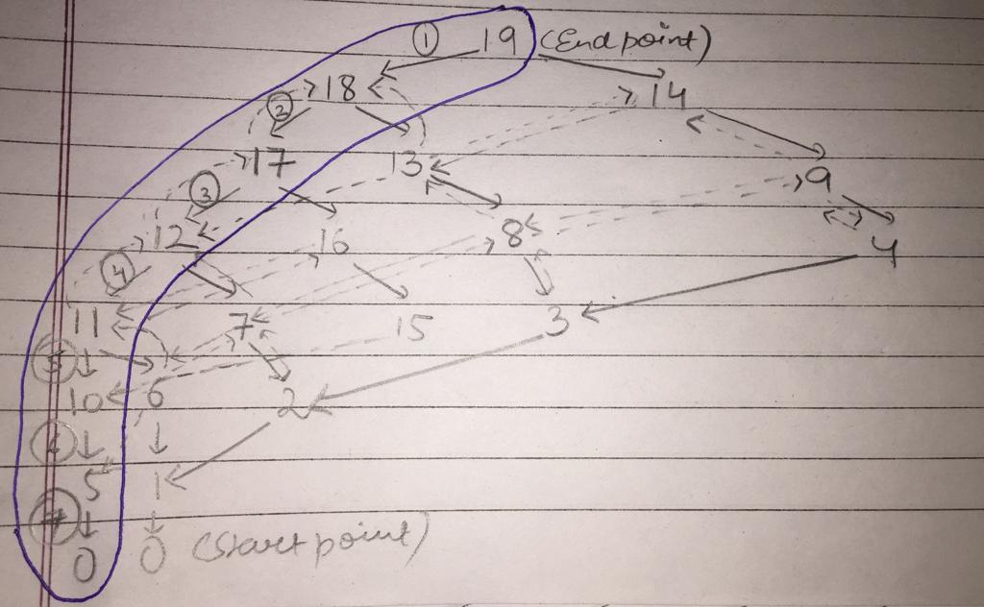

Image 1: Shortest path without blockers (7 units) w.r.t Ans.1 is 19 🡪 18 🡪 17 🡪 12 🡪 11 🡪 10 🡪 5 🡪 0

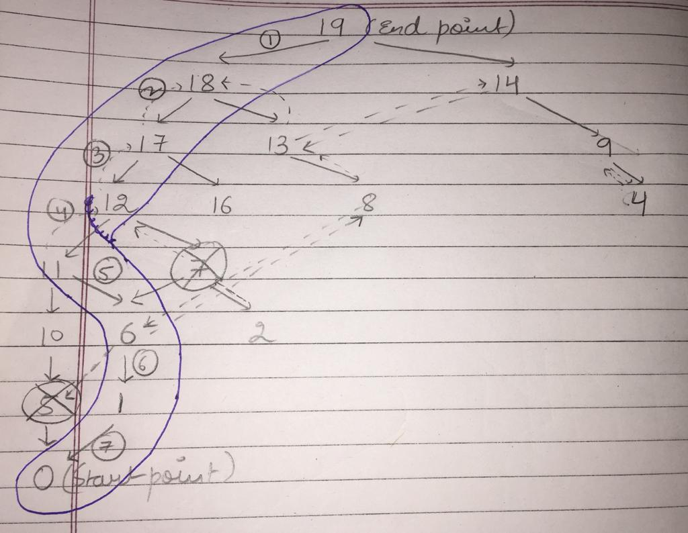

Shortest path with blockers at 5th and 7th squares will lead to change of route from 11th square to 6th square in order to reach the start point in minimum steps because if we will move to 10th and then to 6th then it will increase the distance from 7 to 8 units.

**So, the shortest path with blockers will be: 19 🡪 18 🡪 17 🡪 12 🡪 11 🡪 6 🡪 1 🡪 0**

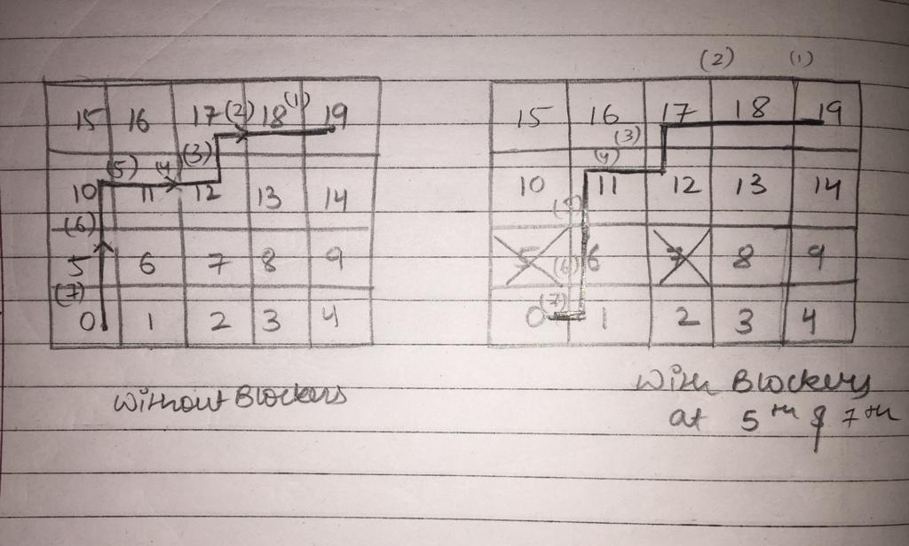

Submitted by: Tavleen Bajwa